Lab 06 Selection, Query, Data Management

Please copy the data to your owner folder.

1.Selection and Query
- Select by attribute (attribute query)
- Select by location (spatial query)
- Combine spatial and attribute query
- Export selected feature data to shape file

1.1 Select by Attribute
Question: Select wetlands which area > 300000

arcpy.management.SelectLayerByAttribute(in_layer_or_view, {selection_type}, {where_clause}, {invert_where_clause})

01. Select by Attribute
# Description: Extract features to a new feature class based on an attribute query
# Import system modules

import arcpy

# Set the workspace
arcpy.env.workspace = r'C:\Users\Desktop\TeachingExercise\data’
arcpy.env.overwriteOutput = True

#Select wetlands which area >= 300000
wetlands_sel=arcpy.management.SelectLayerByAttribute('mc_wetlands.shp', 'NEW_SELECTION', 'AREA >= 300000')
# Write the selected features to a new feature class
arcpy.management.CopyFeatures(wetlands_sel, 'Results/wetlands_300000plus.shp')

print('done')

1.2 Select by location
Question: Find the wetlands which contain zip boundary
arcpy.management.SelectLayerByLocation(in_layer, {overlap_type}, {select_features}, {search_distance}, {selection_type}, {invert_spatial_relationship})
In this function, ‘slection_type’ is “NEW_SELECTION” by default. The resulting selection will replace any existing selection.

02 select_by_location
# Import arcpy and set path to data
import arcpy
arcpy.env.workspace = r'C:\Users\Desktop\TeachingExercise\data’
arcpy.env.overwriteOutput = True

# Make a layer and select wetlands that within the zip polygon
wetlands_zip = arcpy.management.SelectLayerByLocation('mc_wetlands.shp', 'CONTAINS', 'zip.shp')

# Write the selected features to a new feature class
arcpy.management.CopyFeatures(wetlands_zip, 'Results/wetlands_zip')

print('done!!')

# count the number of the wetlands within the zip polygon
cnt = arcpy.management.GetCount('Results/wetlands_zip.shp')
print ("The number of wetlands within zip is :" + str(cnt) )

1.3 Combine spatial query and attribute query
Question: Find the wetlands contains zip with area > 300000

03.Combine select by location and select by attribute
# Description: Extract features to a new feature class based on a spatial relationship to another layer # and an attribute query

# Import system modules
import arcpy

# Set the workspace
arcpy.env.workspace = r'C:\Users\Desktop\TeachingExercise\data’
arcpy.env.overwriteOutput = True

# Select all wetlands within zip and area is large than 300000
wetlands_zip = arcpy.management.SelectLayerByLocation('mc_wetlands.shp', 'CONTAINS', 'zip.shp')
wetlands_zip_300000plus = arcpy.management.SelectLayerByAttribute('wetlands_zip', 'SUBSET_SELECTION', 'AREA > 300000')

# Write the selected features to a new feature class

out_f=arcpy.management.CopyFeatures(wetlands_zip_300000plus, 'Results/wetlands_zip_300000plus')

print('done')

2. Data Management

2.1 SearchCursor
List out all the county name
import arcpy

arcpy.env.workspace = r'C:\Users\Desktop\TeachingExercise\data’
arcpy.env.scratchWorkspace = r'C:\Users\Desktop\TeachingExercise\data’

arcpy.env.overwriteOutput = True

fc ="New_York_State.shp"
with arcpy.da.SearchCursor(fc,["NAME"]) as cursor:
for row in cursor:
#print ("County name = {0}".format(row[0]))
print(f'County name = {row[0]}.')

2.2 UpdateCursor
UpdateCursor (in_table, field_names, {where_clause}, {spatial_reference}, {explode_to_points}, {sql_clause}, {datum_transformation})

updateCursor
import arcpy

arcpy.env.workspace = r'C:\Users\Desktop\TeachingExercise\data’
arcpy.env.scratchWorkspace = r'C:\Users\Desktop\TeachingExercise\data’
arcpy.env.overwriteOutput = True

fc ="New_York_State.shp"
field_names = "NAME"
where_clause = 'NAME=\'Albany\''

# Create update cursor for feature class
with arcpy.da.UpdateCursor(fc, field_names, where_clause) as cursor:

# For each row, evaluate the NAME value (index position of 0), if the value of NAME is 'Albany',update it to 'Albany-NYS'

for row in cursor :
row[0] = "Albany-NYS"
cursor.updateRow(row)

print ("update process done")

2.3 insertCursor
InsertCursor (in_table, field_names, datum_transformation)
insertCursor, insertRow
import arcpy

arcpy.env.workspace = r'C:\Users\Desktop\TeachingExercise\data’
arcpy.env.scratchWorkspace = r'C:\Users\Desktop\TeachingExercise\data’
arcpy.env.overwriteOutput = True

fc ="New_York_State.shp"
field_names =["NAME", "COUNTYFP"]
field_values =[("COUNTY-1", "000"), ("COUNTY-2", "000")]

with arcpy.da.InsertCursor(fc,field_names) as cursor:
for row in field_values:
cursor.insertRow(row)

print ("insert process done")

2.4 Add a new field to feature class
management. AddField
Add a new field to a feature class. But before add, better to validate the new field name
Syntax

arcpy.management.AddField(in_table, field_name, field_type, {field_precision}, {field_scale}, {field_length}, {field_alias}, {field_is_nullable}, {field_is_required}, {field_domain})

AddField management, with validateFieldName
import arcpy

arcpy.env.workspace = r'C:\Users\Desktop\TeachingExercise\data’
arcpy.env.scratchWorkspace = r'C:\Users\Desktop\TeachingExercise\data’
arcpy.env.overwriteOutput = True

fc ="New_York_State.shp"
newfield ="NEW FID"
field_type = "TEXT"
field_length =12
newfield_name = arcpy.ValidateFieldName(newfield)
arcpy.management.AddField(fc, newfield_name, field_type,"","",field_length)

print ("AddField_management process done")

Validate Fieldname
It prevents attempts to create invalid names, such as those spaces or with invalid characters. All invalid characters in the input string will be replaced with an underscore (_).

https://pro.arcgis.com/en/pro-app/latest/arcpy/functions/validatefieldname.htm

CreateUniqueName
Create a unique feature class name in the specified workspace by appending a number to the input name. These prevent accidently overwriting files.
CreateUniqueName
import arcpy

arcpy.env.workspace = r'C:\Users\Desktop\TeachingExercise\data’
arcpy.env.scratchWorkspace = r'C:\Users\Desktop\TeachingExercise\data’
arcpy.env.overwriteOutput = True

fc ="mc_major_roads.shp"
new_fc = arcpy.CreateUniqueName("Results/buffer.shp")
arcpy.analysis.Buffer(fc, new_fc, "5000 METERS")

print ("buffer process done")

3. Similar Practice for reference:
- searchCursor
- updateCursors
- insertCursors
- Select Extracts features from an input feature class

Search cursors

Example:
find county with ALAND > than 2,500,000,000

SearchCursor with where_clause,
import arcpy
arcpy.env.workspace = r'C:\Users\Desktop\TeachingExercise\data’
arcpy.env.scratchWorkspace = r'C:\Users\Desktop\TeachingExercise\data’
arcpy.env.overwriteOutput = True

fc ="New_York_State.shp"
fields= 'NAME'
where_clause = 'ALAND > 2500000000'

with arcpy.da.SearchCursor(fc,fields,where_clause) as cursor:
for row in cursor:
print(f'County Name = {row[0]}')

Another example:
Find Albany with Feature = ‘Albany’
How to set the where_clause?
Where_clause = ‘NAME = Albany’ ?
No, it will cause error. It should be set to 'Name = \'Albany\''
Where clause field with string
import arcpy

arcpy.env.workspace = r'C:\Users\Desktop\TeachingExercise\data’
arcpy.env.scratchWorkspace = r'C:\Users\Desktop\TeachingExercise\data’
arcpy.env.overwriteOutput = True

fc ="New_York_State.shp"
fields= 'COUNTYFP'
where_clause = 'NAME = \'New York\''

with arcpy.da.SearchCursor(fc, fields, where_clause) as cursor:
for row in cursor :
#print ("COUNTYFP with where_cluase set with {0} is = {1}".format(where_clause, row[0]))
print (f"COUNTYFP with where_cluase set with {where_clause} is = {row[0]}")

Select (Analysis)
Extracts features from an input feature class or input layer, typically using a select or Structured Query Language (SQL) expression and stores them in an output feature class.
https://pro.arcgis.com/en/pro-app/latest/tool-reference/analysis/select.htm
Syntax
arcpy.analysis.Select(in_features, out_feature_class, {where_clause})

Example: Extract from New_York_State.shp where Name = 'New York’, and store the result in a new feature class
Select_analysis with where clause
import arcpy

arcpy.env.workspace = r'C:\Users\Desktop\TeachingExercise\data’
arcpy.env.scratchWorkspace = r'C:\Users\Desktop\TeachingExercise\data’
arcpy.env.overwriteOutput = True

infc ="New_York_State.shp"
outfc= "Results/ny_nys.shp"
where_clause = 'NAME = \'New York\''

arcpy. analysis.Select (infc, outfc,where_clause)

print ("extract process done")

UpdateCursors
https://pro.arcgis.com/en/pro-app/2.8/arcpy/data-access/updatecursor-class.htm

Open the attribute table of ny_nys.shp, you can find that there some miss value of the field “NEW_FID”. The following example use updateCursor to update the empty value of “NEW_FID”
Example: update record where NEW_FID <> NY

UpdateCursor updateRow
import arcpy

arcpy.env.workspace = r'C:\Users\Desktop\TeachingExercise\data’
arcpy.env.scratchWorkspace = r'C:\Users\Desktop\TeachingExercise\data’
arcpy.env.overwriteOutput = True

fc ="Results/ny_nys.shp"
field_names ="NEW_FID"
where_clause = '"NEW_FID" <> \'NY\''

with arcpy.da.UpdateCursor(fc,field_names, where_clause) as cur:
for row in cur:
row[0] = "NY"
cur.updateRow(row)

print ("update process done")

Example: delete record with ALAND < 100000
UpdateCursor deleterow
import arcpy

arcpy.env.workspace = r'C:\Users\Desktop\TeachingExercise\data’
arcpy.env.scratchWorkspace = r'C:\Users\Desktop\TeachingExercise\data’
arcpy.env.overwriteOutput = True

fc ="New_York_State.shp"
field_names ="ALAND"

with arcpy.da.UpdateCursor(fc,field_names) as cursor:
for row in cursor:
if row[0] <100000:
cursor.deleteRow()

print ("delete row process done")

InsertCursors
insertCursors;
import arcpy

arcpy.env.workspace = r'C:\Users\Desktop\TeachingExercise\data’
arcpy.env.scratchWorkspace = r'C:\Users\Desktop\TeachingExercise\data’
arcpy.env.overwriteOutput = True

fc ="New_York_State.shp"
field_names ="NAME"
#field_names =["NAME","COUNTYFP"]

with arcpy.da.InsertCursor(fc,field_names) as cursor:
cursor.insertRow(["TEST_COUNTY"])
#cursor.insertRow(["TEST_COUNTY", 000])

del cursor
print ("insert row process done")

4.Create new feature class and add data to the shapefile

Try the following code:
import arcpy
import sys
import os
import csv

#the directory where data will be processed
arcpy.env.workspace = r'C:\Users\Desktop\TeachingExercise\data’
arcpy.env.overwriteOutput = True

out_workspace = '/Results'

#setup the output feature class
print ("creating new feature class")

#need to define a projection to display correctly
prj = "wgs_84.prj"

#create the shape file using ArcPy - https://pro.arcgis.com/en/pro-app/latest/tool-reference/data-management/create-feature-class.htm
Output_FC = arcpy.CreateFeatureclass_management(out_workspace, "311.shp", "POINT","","DISABLED","DISABLED", prj)
print ("finished creating new feature class")

#the CSV file coming in, the contents will be written into the shapefile

file_in = r'C:\Users\jiahe\Desktop\TeachingExercise\24-25\Selection_Query\data\311_Harvey_small.csv'

#define the fields from the CSV that will be accessed
LAT_field = "LATITUDE"
LON_field = "LONGITUDE"
OVERDUE_field = "OVERDUE"
SR_TYPE_field = "SR TYPE"

#define fields in shapefile
fieldName_RecordId = "record_id"
fieldPrecision = 9
fieldAlias = "refcode"

fieldName_Overdue = "overdue"

fieldName_sr = "sr_type"
fieldLength = 255

#create fields in the new shapefile - https://pro.arcgis.com/en/pro-app/latest/tool-reference/data-management/add-field.htm
arcpy.AddField_management(Output_FC, fieldName_RecordId, "LONG", fieldPrecision, field_alias=fieldAlias, field_is_nullable="NULLABLE")
arcpy.AddField_management(Output_FC, fieldName_Overdue, "DOUBLE", field_length=fieldLength)
arcpy.AddField_management(Output_FC, fieldName_sr, "TEXT", field_length=fieldLength)

#open the CSV for reading its contents
with open(file_in) as csvfile:
#read the CSV as a dict - i.e, key:value pairs - https://docs.python.org/3/library/csv.html#csv.DictReader
current_data = csv.DictReader(csvfile)
#seed the unqiue ID value, start at 0
rowidval = 0
#begin for loop of the CSV dict object and access of the CSV fields defined previosuly starting on line 28
for row in current_data:
#inspect the coordinate values
print("Coord:" + row[LAT_field] + "," + row[LON_field])
try:
#the fields in the shape file that were
fields = [fieldName_RecordId,fieldName_Overdue, fieldName_sr, 'SHAPE@XY']
#a cursor is used to read/write data to the shapefile
#this code will access the shapefile to beging editing - https://pro.arcgis.com/en/pro-app/latest/arcpy/data-access/insertcursor-class.htm
cursor = arcpy.da.InsertCursor(Output_FC, fields)
#convert the lat and long from the CSV into a list of float values
xy = (float(row[LON_field]), float(row[LAT_field]))
#write a new row of data into the shapefile using the contents of the CSV that is currently in the loop
#the order of data being writen has to be the same as the varibale fields defined around line 62
cursor.insertRow((rowidval, float(row[OVERDUE_field]),row[SR_TYPE_field],xy))
#increment the unqiue ID value by 1 to get ready for the next iteration of the loop
rowidval += 1
except Exception:
#catch any errors that might happen
e = sys.exc_info()[1]
print(e.args[0])
#delete cursor object from memory so the final shapefile can be accessed when the code is finished
del cursor
print ("done")

Geometry token
Additional information can be accessed using tokens (such as OID@) in place of field names:
- SHAPE@XY —A tuple of the feature's centroid x,y coordinates.
- SHAPE@TRUECENTROID —A tuple of the feature's true centroid x,y coordinates.
- SHAPE@X —A double of the feature's x-coordinate.
- SHAPE@Y —A double of the feature's y-coordinate.
- SHAPE@Z —A double of the feature's z-coordinate.
- SHAPE@M —A double of the feature's m-value.
- SHAPE@JSON — The esri JSON string representing the geometry.
- SHAPE@WKB —The well-known binary (WKB) representation for OGC geometry. It provides a portable representation of a geometry value as a continuous stream of bytes.
- SHAPE@WKT —The well-known text (WKT) representation for OGC geometry. It provides a portable representation of a geometry value as a text string.
- SHAPE@ —A geometry object for the feature.
- SHAPE@AREA —A double of the feature's area.
- SHAPE@LENGTH —A double of the feature's length.
- OID@ —The value of the ObjectID field.

Assignment

Ex01:
Find out the schools which is within the buffer. School name[SCHOOL], address[NY_ADDR], (x,y) coordinate should be print out.
Answer：

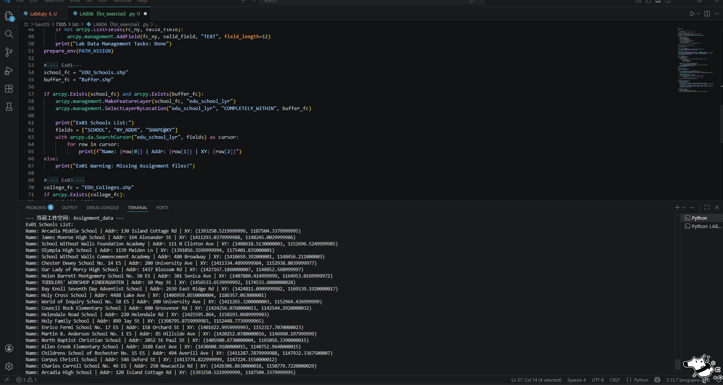

Ex02:
Modify ex01, let users select source and boundary feature class. Tips: use arcpy.GetParameterAsText(0) to get parameter. Use arcpy.AddMessage to print the messages of the results.
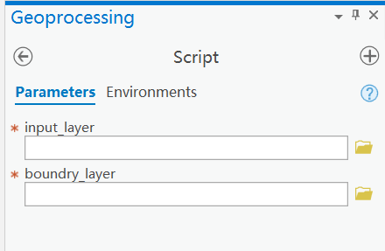
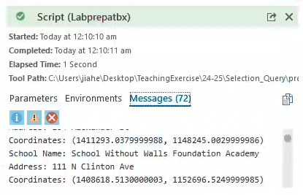
Answer：
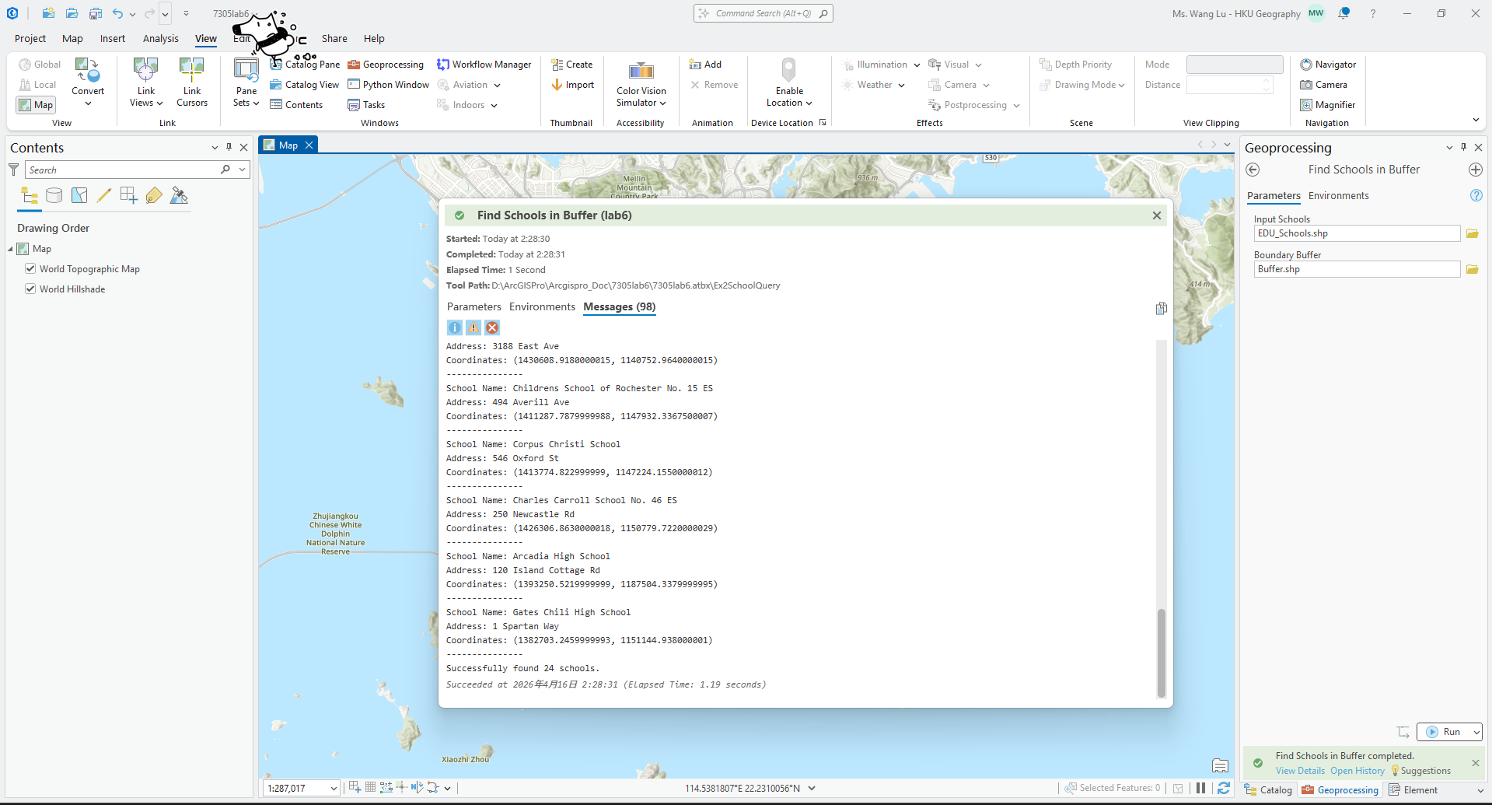

Ex03:
Write a script that create a 1500-meter buffer around features in the EDU_Collages.shp feature class classified as an “Public” (based on the TYPE field), and create a 750-meter buffer around features classified as a “Private”. The results should be two separate feature classes.
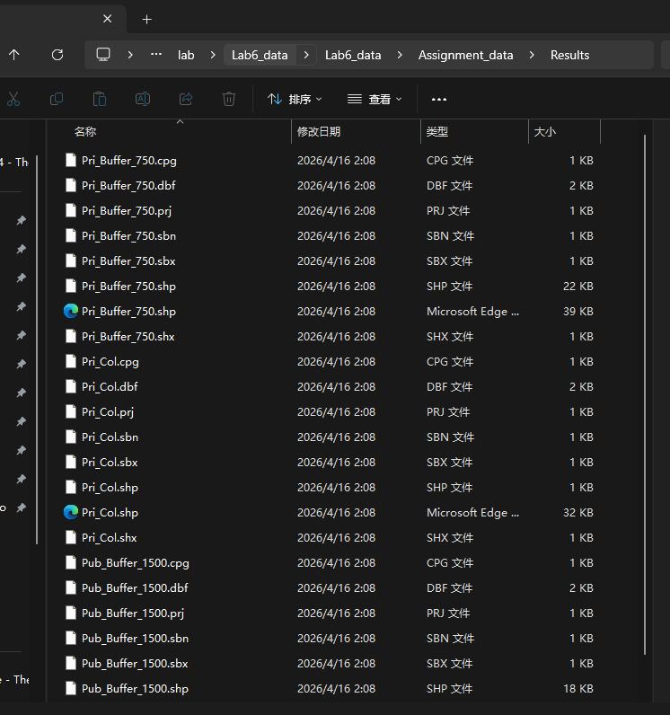

Ex04:
Write a script that adds a text field to the EDU_Collages.shp feature class called “PUBLIC” and populates this field with “YES” and “NO” values, depending on the value of the “TYPE” field.
